Climbfest 2023 Inishowen Topo Guide
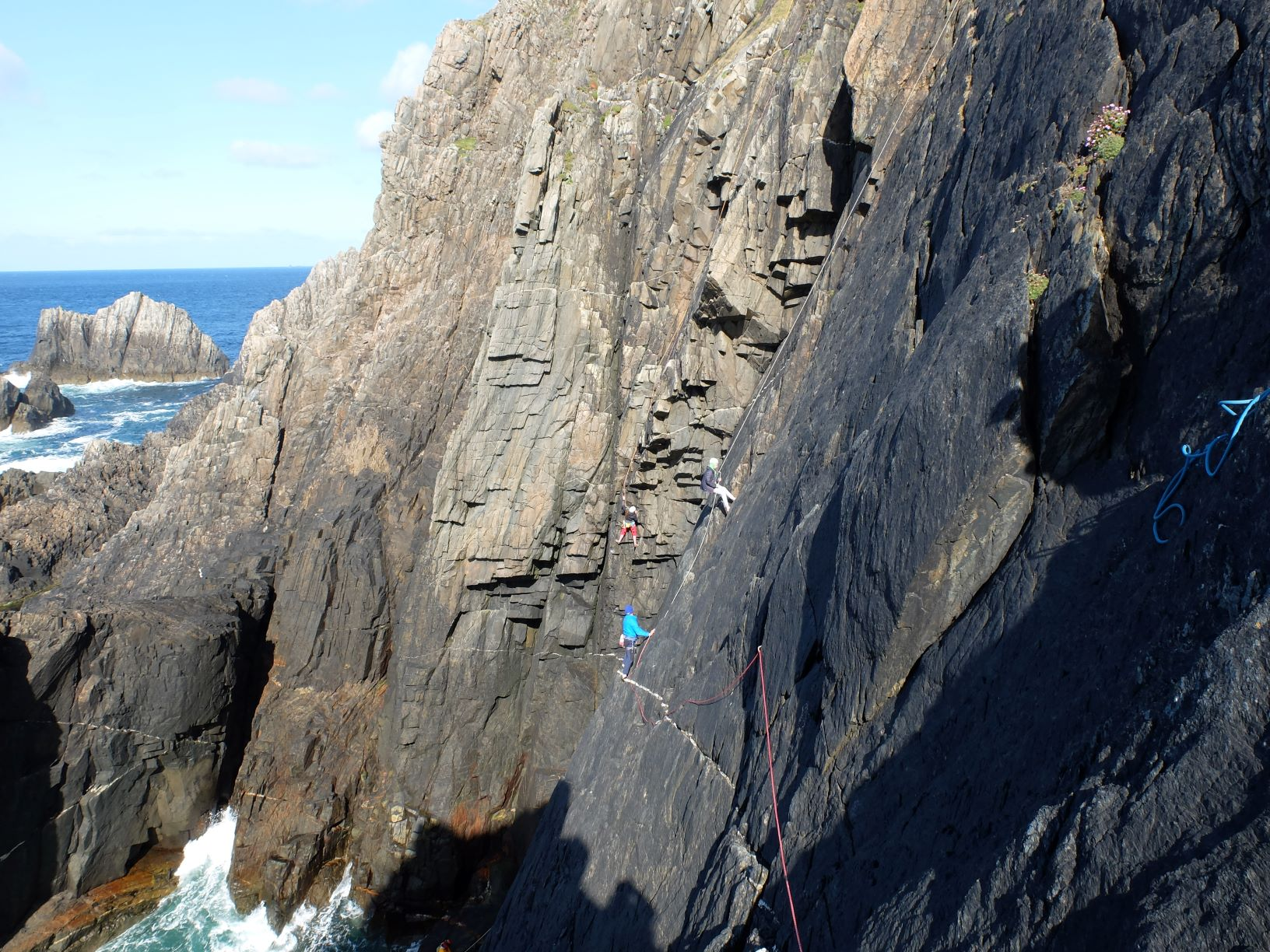

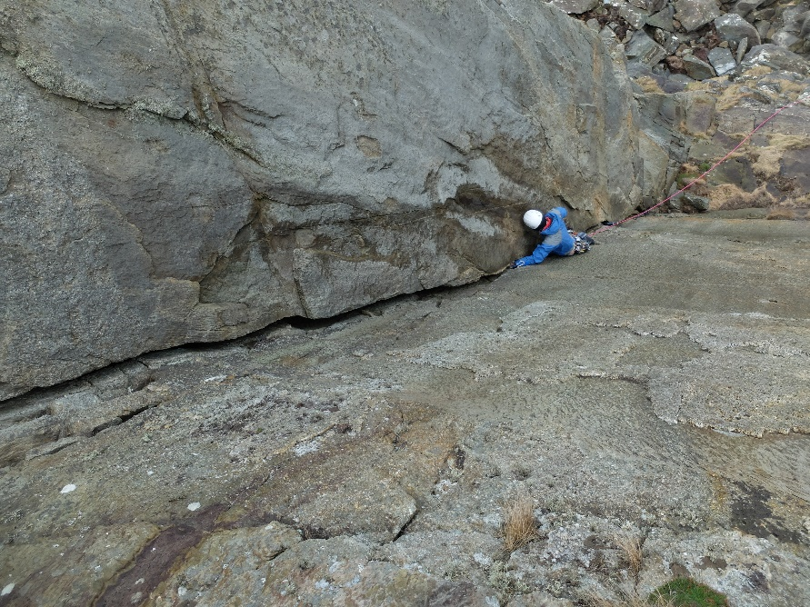
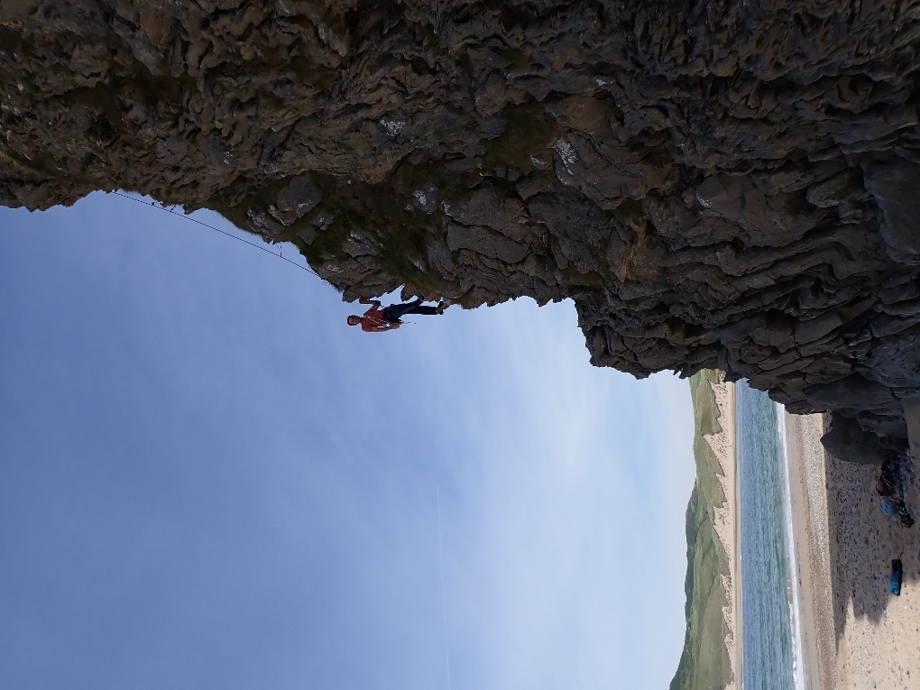

Selected Climbs
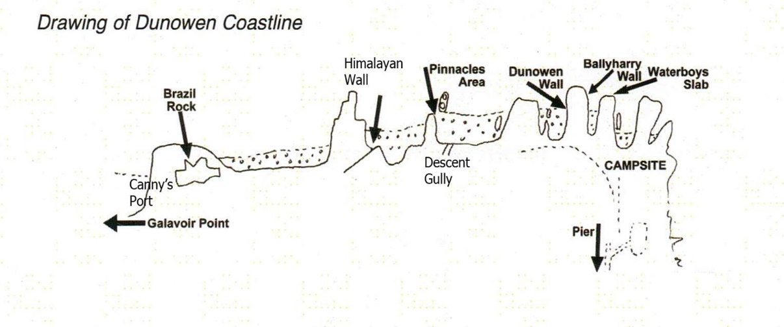

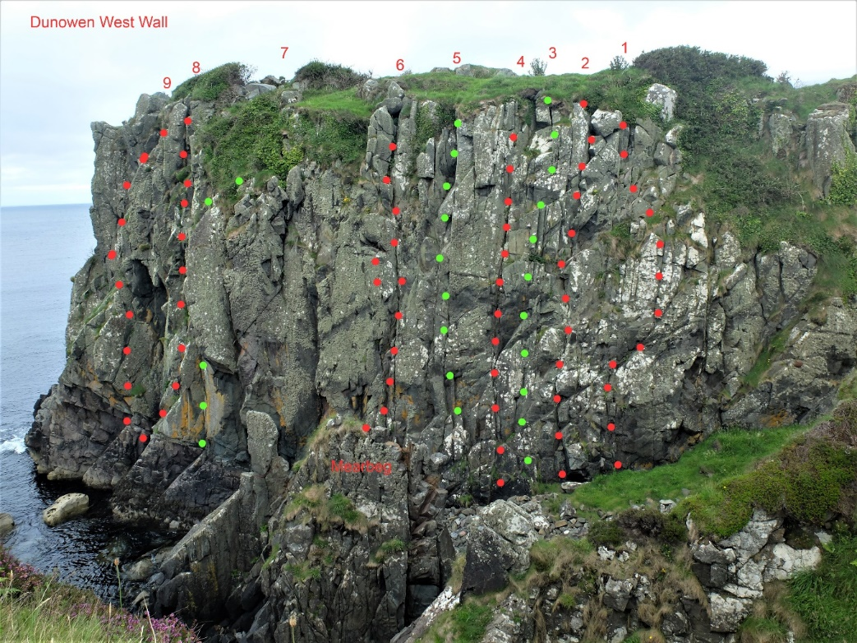
Guide to climbs at Bunagee Climbers Campsite
Dunowen.
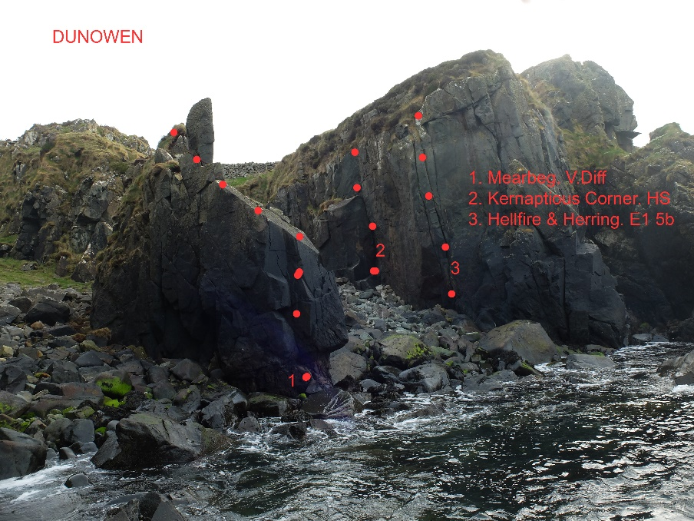
Approaching through Carndonagh and Culdaff, Colmcille Climbers have a camping area and car park just beyond the pier at Bunagee Gr C 53778 50828 If the gate is locked you can park by the pier. This gives access to the Dunowen Crags, but access from here to the Pinnacle Bay cliffs and Brasil Rock has been closed off by the landowners, so a different approach has to be taken (unless you are prepared to avail of a short Via cordata around the headland). Dunowen West Wall is the west-facing face of the promontory fort, accessible through the swing gate from the campsite. Hereabouts there are 30+ routes in total, less than 100m from the campsite. The rock is grippy but should be treated with respect, and needs cleaned regularly to prevent it being recovered by the lichen and sundry vegetation.
- 1.Dreapadoireachta. HS 4b
- 2 Miss Conception. Sev 4a
- 3 Mingus Eyes. HS 4b
- 4 Graina’s Groove. HS 4b
- 5 Blondes. VS 4c
- 6 Glengad Girls. HS 4b
- 7 Kerry Widow. HVS 5a
- 8 Angels. VS 4c
- 9 Whiter Shade of Pale. VS 4b
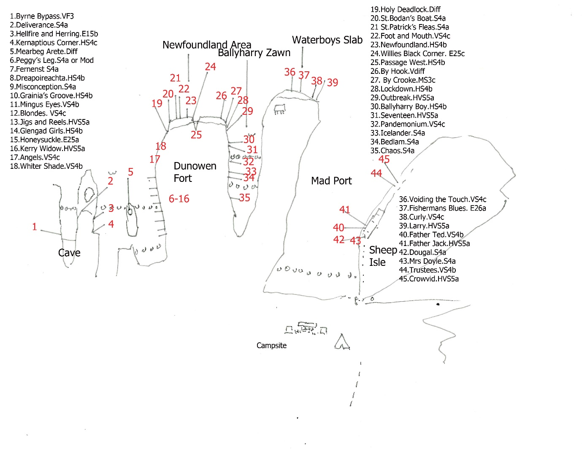

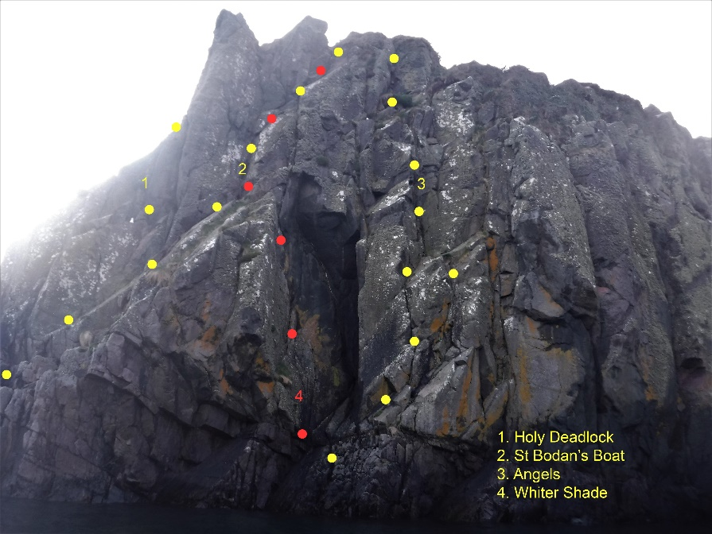
Holy Deadlock. V.Diff
St Bodan’s Boat. Sev 4a
Angels. VS 4c
Whiter Shade of Pale. VS 4b
By Hook. V.Diff
Passage West. HS 4b
Newfoundland. HS 4b
Foot and Mouth. VS 4c
St Patrick’s Fleas. Sev 4a
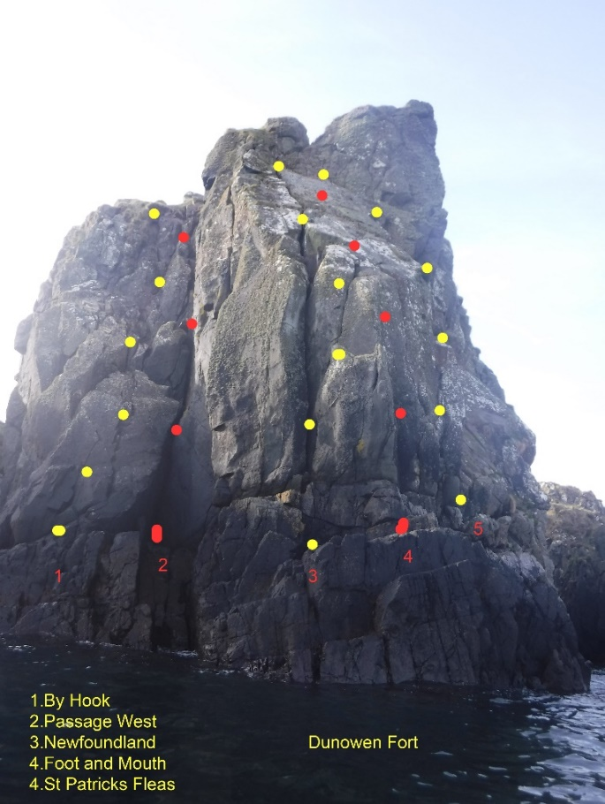
Newfoundland Area
The routes above are all on the seaward
end of Dunowen Promontary Fort.
Descent is by abseil.

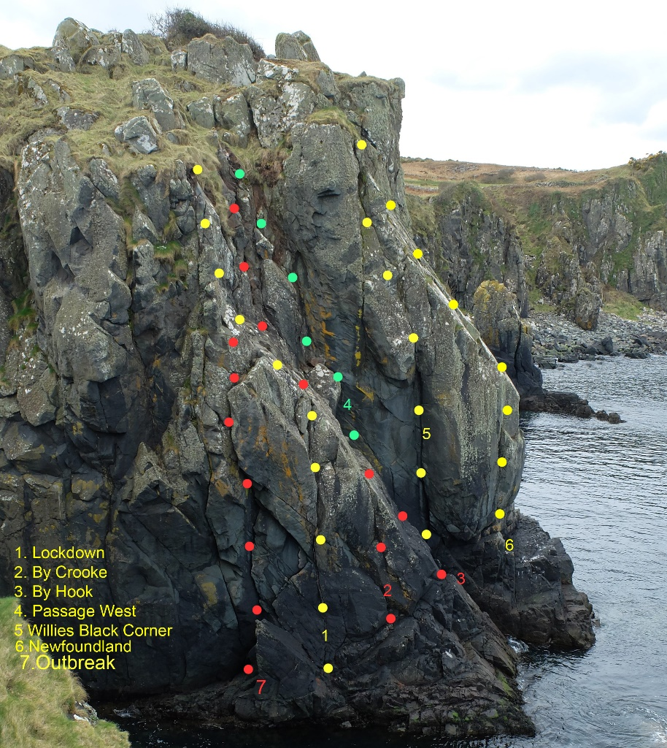
Lockdown. HS 4b
By Crooke. V.Diff
By Hook. V.Diff
Passage West. HS 4b
Willies Black Corner. E2 5b
Newfoundland. HS 4b
Outbreak. HVS 5a

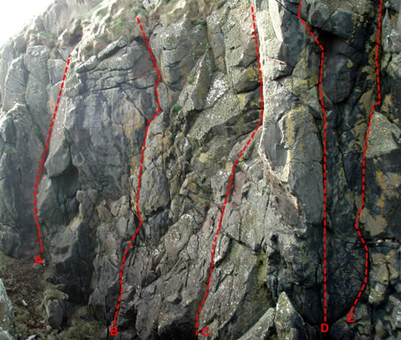
In Ballyharry Zawn
A. Chaos. Sev 4a
B. Bedlam. Sev 4a
C. Pandemonium. VS 4c
D. Seventeen VS 4c
E. Ballyharry Boy. VS 4b

Waterboys Slab
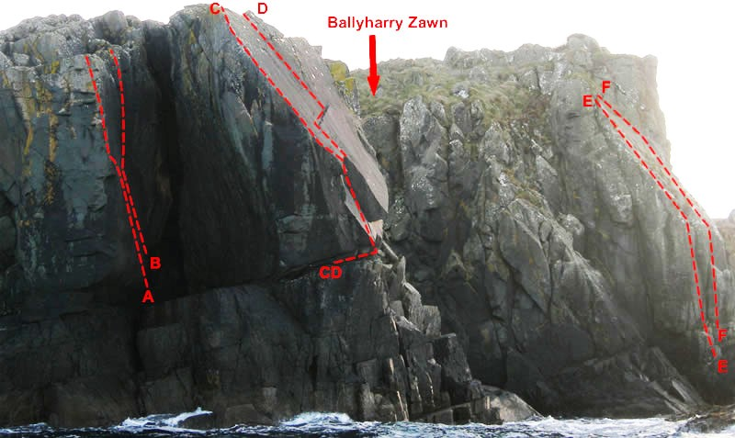
At the end of the next promontory is a fine slab with a couple of delicate hard climbs, currently desperately needing a good clean (hint). Descent by abseil.
A. Curly VS 4c
B. Larry. HVS 5a
C. Fisherman’s Blues E2 5b
D. Touch. VS 4c
E. Newfoundland. HS 4b
F. Foot and Mouth. VS 4c

Madrox are on the west facing side of Sheep Island. Descend along a rocky ledge.
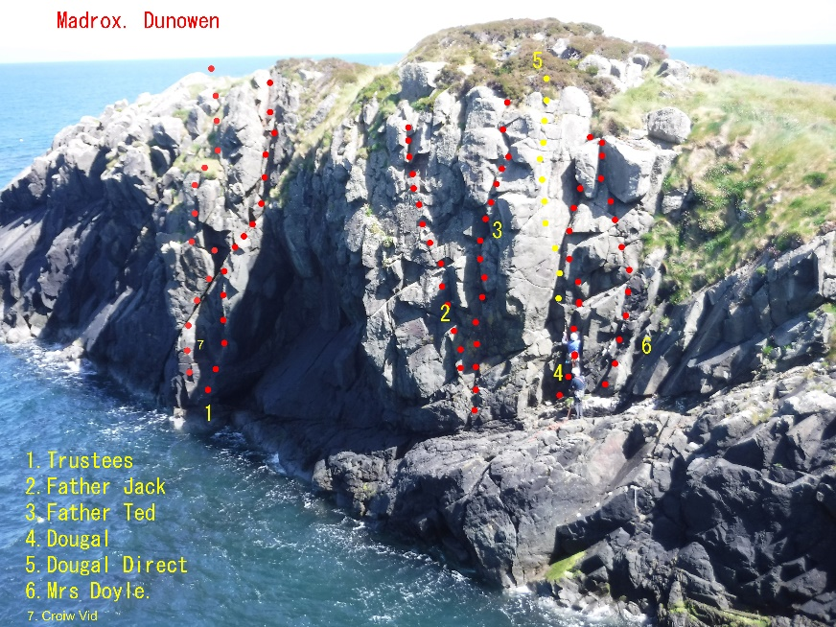
Trustees. VS 4b
Father Jack. HVS 4c
Father Ted. VS 4b
Dougal. Sev 4a
Dougal Direct. VS 4c
Mrs Doyle. Sev 4a
Crow-vid. VS 4c

Brasil Rock
Currently access is blocked to the pinnacle bay climbs to the west, and Brasil Rock sadly cannot now be accessed from the campsite by the Fisherman’s Track. The alternative route takes you back along the road towards Culdaff. Take the first right,uphill to a T junction, turn right, and park on the left by a small quarry/black hut Gr C53579 49257. Just opposite is an overgrown cart track on the edge of a field (close wire gate after you) which leads down past a small ruin, into a field, which gives access, over a tumble down wall, to the rough ground above the shore, very close to Himalayan Wall (right) and Brazil Rock (left)! (20 minute walk, or 2 minutes in the car to the lane).
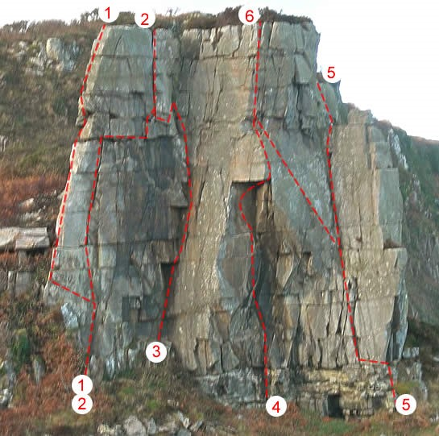
1.Alhambra. V.Diff
2.Bunratti Pillar. HVS 5a
3.Zanzibar. E1 5a
4.Start of Something New. E4 6a
5.Broadbinn’s Emporium. Sev 4a
6.Croca-Corolla HVS 5a
A. Apex. HVS 5a
B.Bunagee Bluegrass Boys. V. Diff
C. The Hustler. HS 4b
D.Moonstruck. HVS 4c
E. Cap Gun Corner. Sev 4a
F. Expertise. HS 4b

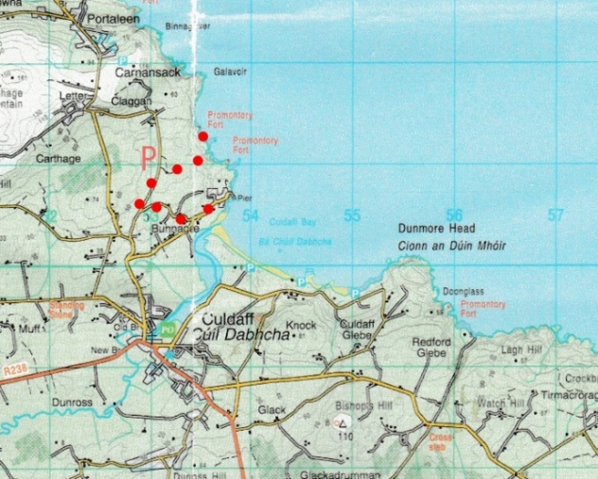
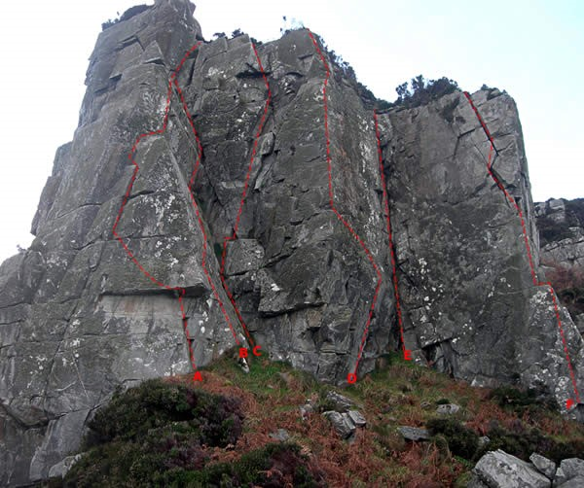

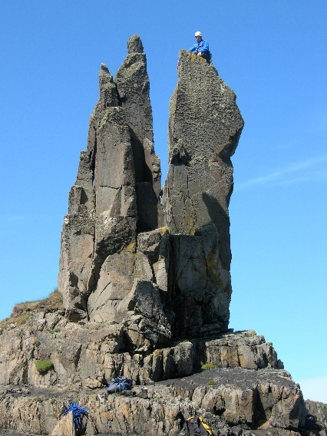
Himalayan Wall
Rhumdoodle** HS 4b.
My Friend Bill*. VS4c.
Eviction Notice Served** E2 6c.
Flight of Fancy** HVS 5a.
Himalayan Dream** Sev 4a.
Bogged til the Oxters*** VS 4c.

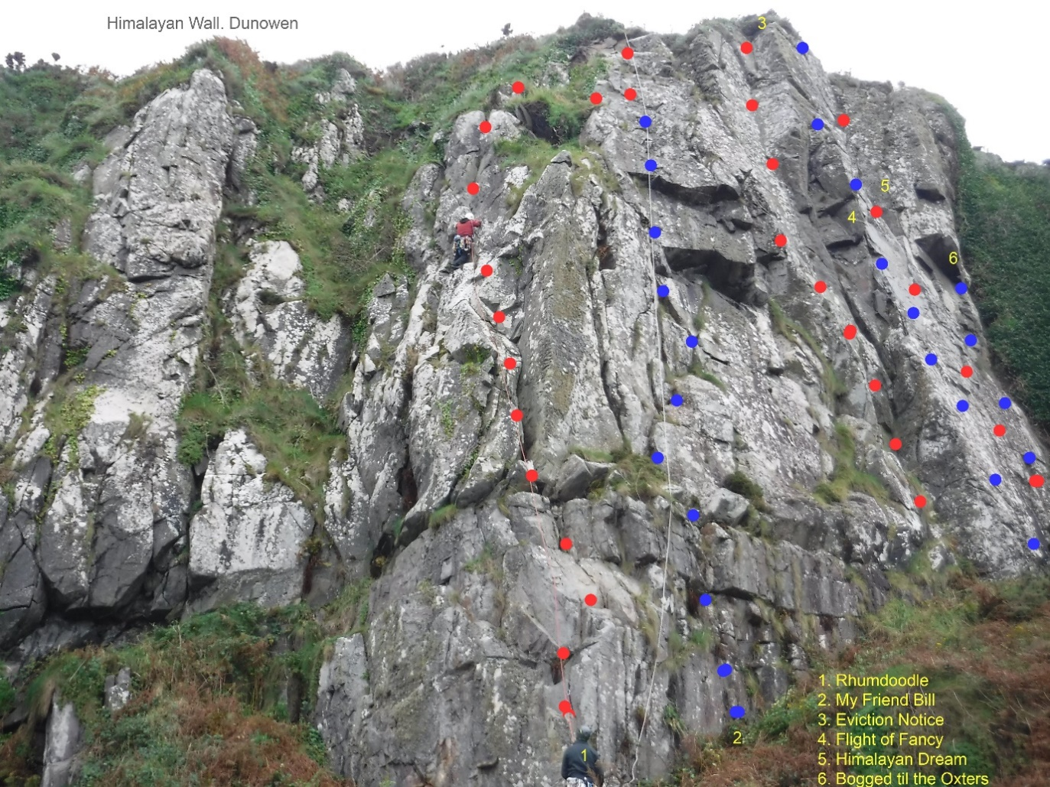

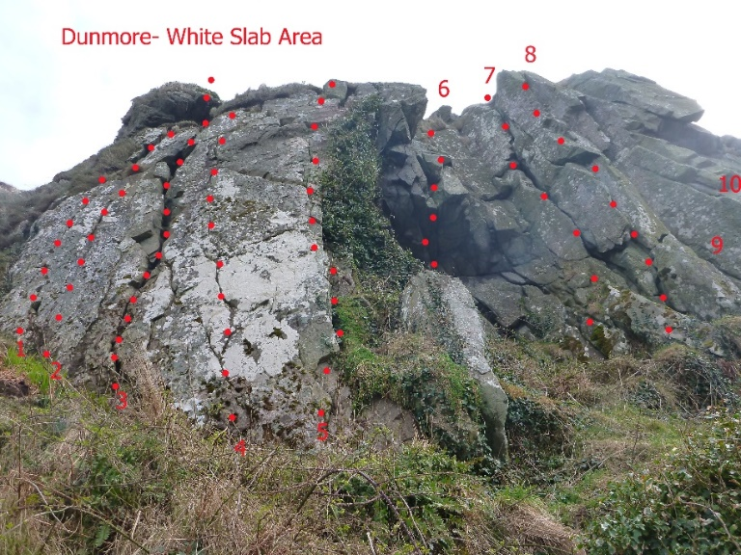
Dunmore Head
Donegal’s Dalkey, this fine gritstone outcrop has the advantages of a great variety of routes of all grades, on sound rock, and convenient to parking, which is available opposite to the caravan site by the beach. Be careful to locate the track into the crag, left of the gateway.

- Toenails. Sev 4a
- Tweezers. Sev 4a
- Dusty Mayday. Diff
- Caratra Crack. VS4c
- Oxo in October. Sev 4a*
- The Wurtitzer. E2 6a*
- Calamity Collins VS4c
- Ten CC. E1 5b*
- Peapod. VS4b**
- Fluid Inclusions. HVS 5a**

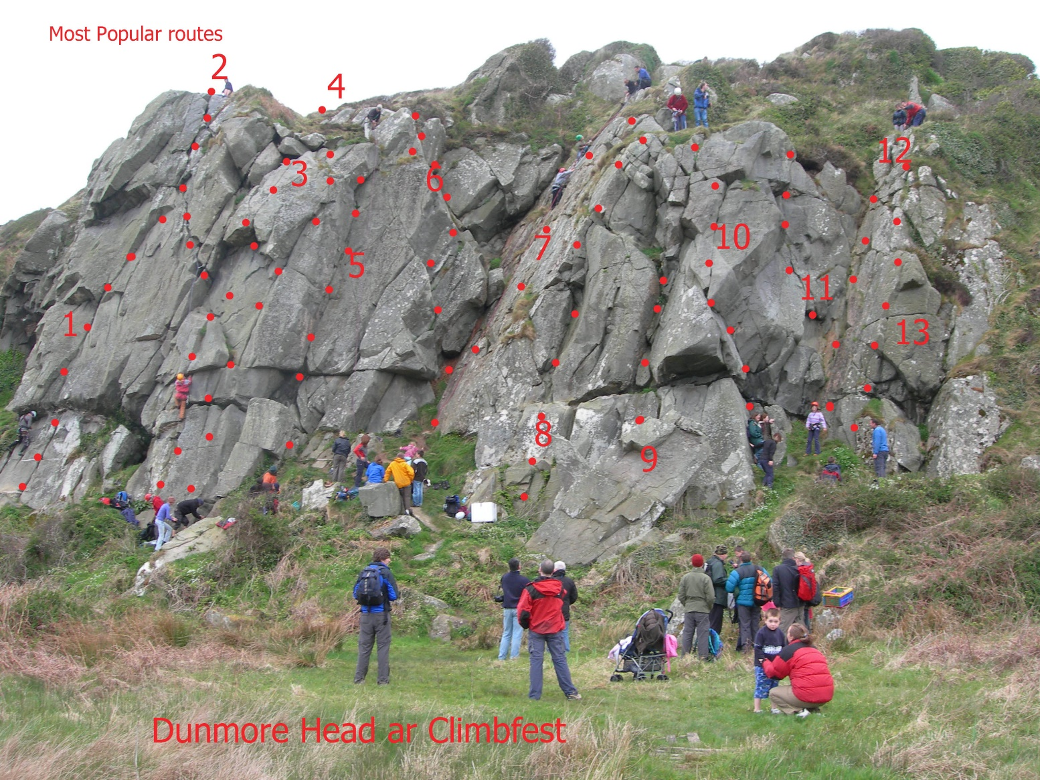
- Shiny Cossacks HVS 5a**
- Diversion. HS 4b***
- Master of Puppets. HVS 5b**
4 Grecian Gift. VS 4c *
5 Orange Blossom. HS 4c**
6 Cheatin Bitch. Sev 4a*
7 SRS Slab. Diff*
8 Belfast Blitz Boys. MS
9 Absent Friends. VDiff
10 Absent Friends 5. VS 4b
11 Birds Nest Bulge. Sev 4a
12 Bluebelle. Diff.
13 Coca Cola. Diff
Dunmore Head, North Face
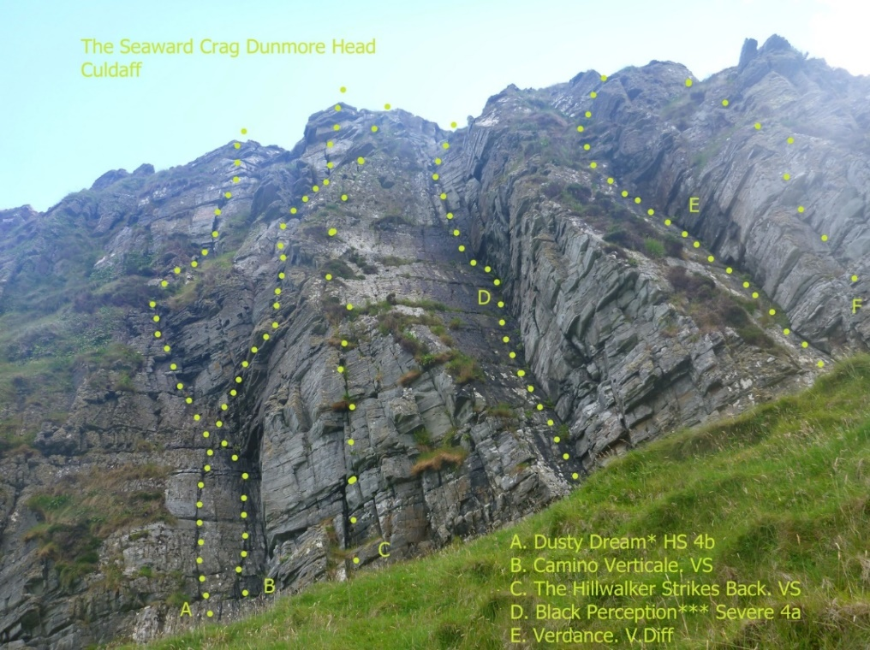
Approach either along the shore below the other Dunmore crags, or over the wall at the top of the descent gully of the main Right Hand crag. About 5 minutes walk, this mainly vegetated north facing crag has a number of quality routes at it's west end, most of which are longer than the others at Dunmore. Route F on the Topo is 'Gofrit', about Severe.

Finbarr Wall Gr C357 500
Directions:
A delightful cragette. To get to it from the top of the main crag, go over the headland in a North-East direction until you arrive at the top of the crag overlooking the sea.
Alternatively walk to the immediate skyline (above the main crag) and go through the gate, below and right, follow the path on the wall's left hand side; towards the sea. This approach gains the base of the crag easily.
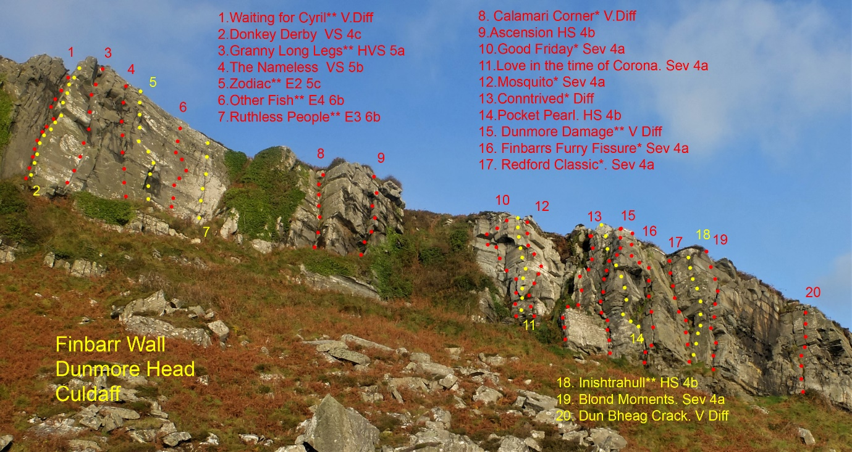

Warm Bay Point (Croaghdoo) Gr 611476
Directions: Access to the crag can be gained via following the coastal road between Tremone Bay and Kinnagoe Bay. Take directions for Kinnagoe Bay (see Donegal Guide). Take a signposted turn off left for Culdaff, 500m before the turn for Kinnagoe crag. Drive for approximately 1.15 miles to a section of open farmland and park next to a gate at 806474. Hop over the seaward wall and continue over field at first and then heather to a jutting peninsula. This is Warm Bay Point, the crag lies on the lower eastern flank (as you are looking northwards/out to sea, to the right). Descend the steep heather, (with the prominent rocky headland of Croaghdoo on your left) via a steep, exposed, cultivated path with fixed rope to the crag. Three areas of rock have been developed to date. An upper, middle and lower crag, the latter being tidal.
Sea Wall Routes (Lower Crag)
A. High Stakes, Sev 4a. McGuigan, Tees 05
B. Croaghdoo Girdle, VD, A.Millar,Sittlington 03
C. Ace of Spades**, VD. A& P Tees 04
D. Two of Clubs*, VD. McGuigan, Tees 03
E. Scannan Na Seachtan*, E1 5b, Cooper, D.Millar 03
F. Dusty Zebra, VD. Magowan, Ryan 04
G. American Pie*, VS 4c. D.Millar, Cooper 03
H. Ramona Sev.4a. Cooper, D.Millar 05
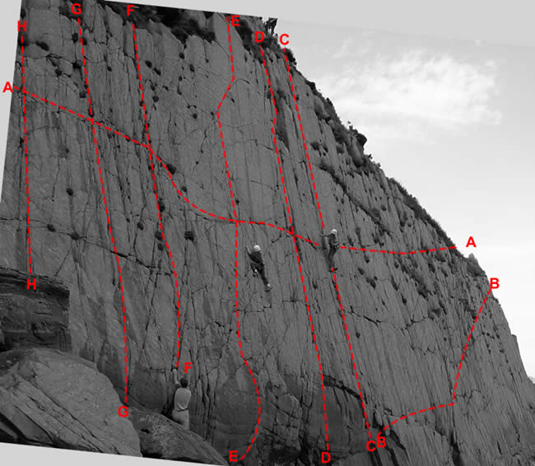

Warmbay, Upper and middle Crag

Some quality climbing here, and well worth the difficult descent!

A. No More Kenny* HVS 5a. A. & D. Millar 04
B. I was belayed by a Cyclops* HVS 5b. A.& D Millar, Hamilton 04
C. Scabby Tails and Sexuality* HVS 5b. A. Millar, Boyle, Cooper 03
D. Bee Eater Sev 4a. McGuigan, Magowan 04
E. Bee Line VD. Tees, McConnell, 05
F. Wheelbarra Crack Diff. McConnell, Tees 05
G. Machinegun Kelly**, VS 4c. Tees 04
H. Punic Palace* VS 4c. Tees, Cooper, Ryan 04
I. Face Clash HVS 5a. Cooper, Ryan 04
J. Jackass* E2 5b. D.Millar, Cooper 04
K. Rockstown Rumble** E1 5b. A.Millar, Boyle, Cooper 03
L. Mittellegi Blues**, Sev 4a. Tees, McGuigan 09
M. Awristocrack, Sev 4a, Tees 09
N. Wan Fut in the Grave*, VS 4b, Tees, McGuigan 09
O. Garwallagh, Sev 4a, Tees, Cooper 08
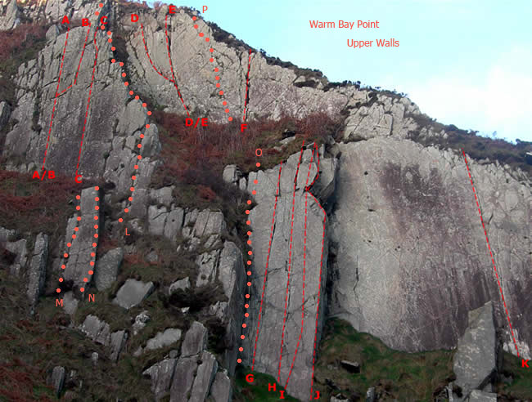
P. Dementia, VS 4b, Tees, PJ Monaghan, McConnell 09

Dungloon ( Kinnego Bay) Gr C630 470
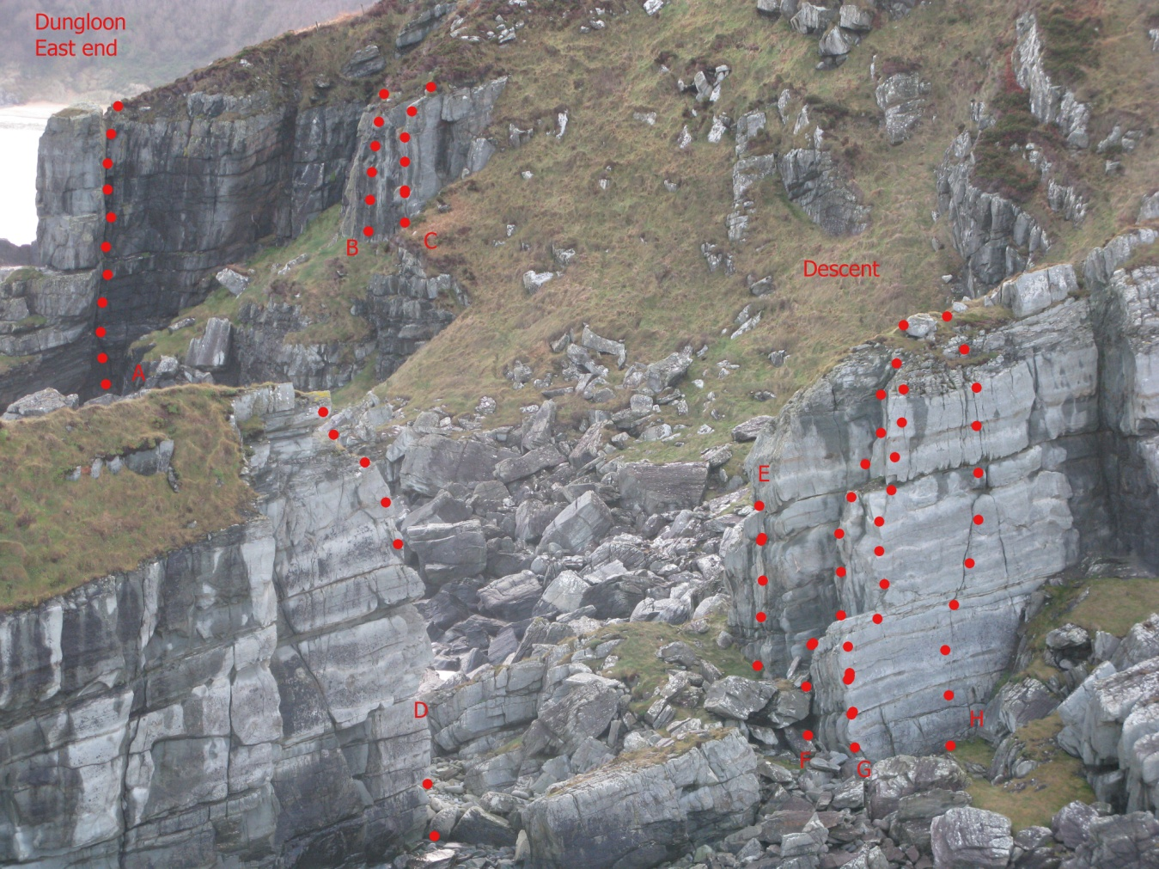
Directions: Kinnego Bay.The various cliffs around the headlands and islands of Dungloon provide good quality climbing in all grades. The longest routes are on the 'Galleon' - a high stack, and are up to 40m in height.
From Moville take the Culdaff Road. Approx 5km from Moville turn right toward Carrowmena, and the next right again past a chapel. Follow this road for approx 6km and turn L just before the steep hill to the beach. Park at the end of the road, and walk N along a lane, then field edges to the top of the cliffs to Gr 62930 46891 and take a steep zig zag descent path.
East End
A. El Capitano**, VS 4c, 27m. McDermott, Rotherham 80
B. Lucy*, HS, 7m. Grant 79 (or route 1 below)
C. Maeve, HS, 7m. Grant 79 (or route 2 below)
D. Cup of Sugar, VS 4b, 10m. Somers, Patton 81
E. Protestant Backlash, HS 4b, 10m. Stelfox 80
F. Finquin, HS 4b, 10m. Finlay, Quinn 80
G. Reach for It*, E2 5b, 20m. McFarlane, Turley 88
H. Red Duster*** E1 5b, 20m. Manson, Stelfox 80

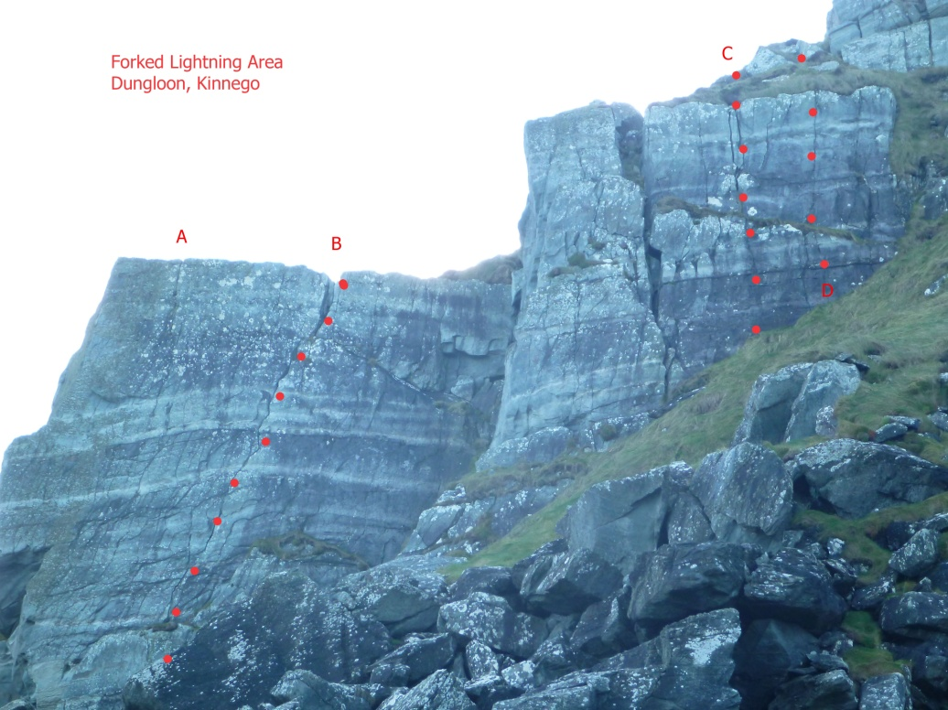

Forked Lightning Area

This includes two of the classics in Donegal. Clamber over the rocks West from The Galleon, and 'Forked Lightning' is obvious on your left.

A. Atlantic Ocean Wall**. E4 6a, 20m. Grimes, Millar 92
B. Forked Lightning*** VS 4c, 20m. Rotherham, Logan 79
C. Trinidad V*. Sev 4a, 12m, Tees, Ward 85
D. San Vicente, VS 4c, 8m. Tees, Deery 91
E. Toad in the Hole, Diff, 15m. Grant 79 ( corner right of Forked Lightning)

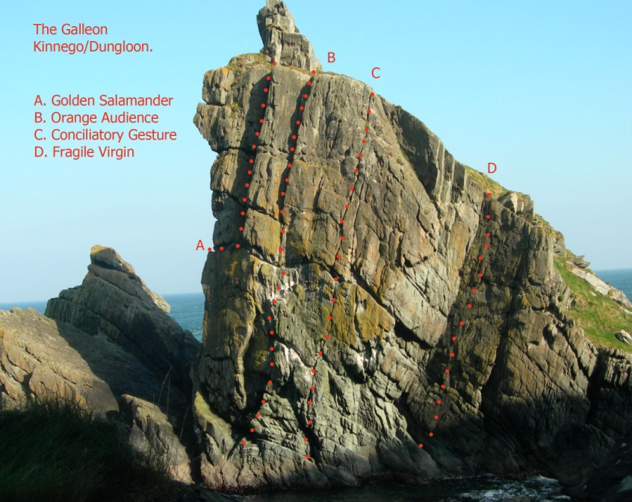
The Galleon
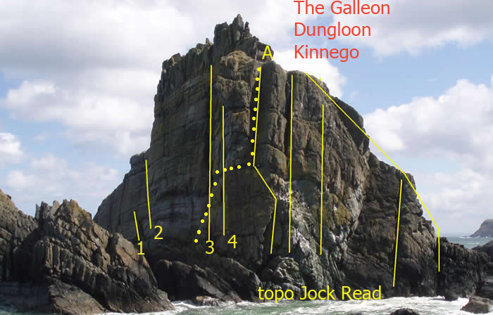
Dungloon Stacks

The Galleon
Galleon Sea Wall
1. Spread your Wings, E1 5b. McCrory, Cooper 81
2. Altered Ego, E1 5b. McFarlane, Mallon 88
3. Freedom Blues, HVS 5a. Stelfox, McFarlane 88
4. Gerrymandering, E1 5a. Stelfox, B-Kerr, Calhoun 89

Crow's Nest
A .Rusty Rigging, Sev 4a, 20m. Rotherham, Grant 79.
B. Midnight Dilemma, E1 5b, 20m. P.& R. Dunlop 87
C. Frigate**, E1 5b, 20m. McFarlane, McQueen 88
D. All Black and Green, E2 5b, 20m. McFarlane, Mallon 88 Golden Hind**. HS 4b (See cover) Tees, McLaughlin 10

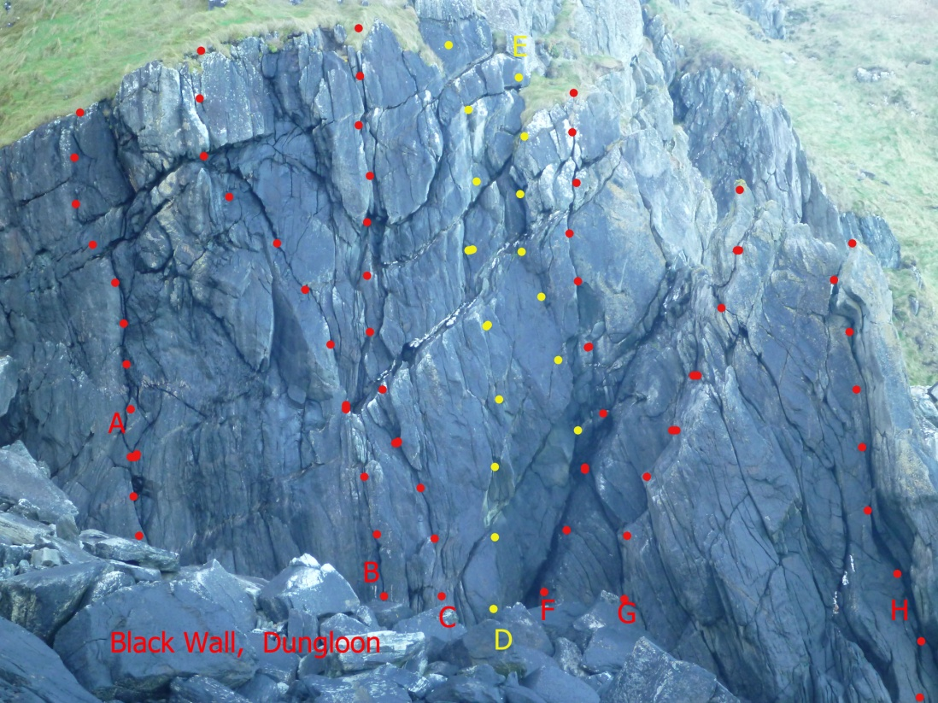
Black Wall Gr 62800 46966

A. Clingen in the rain, HS 4b, 18m. Tees, Ward 84.
B. Foyle Street, VS 4b, 18m. Rotherham, McDaid 80
C. Die Wrecked**, Sev 4a, 18m. Rotherham, McDermott 79
D. Planters' Plunder*, VS 4b, 18m. Stelfox, Manson 80
E. Fuschia , HS 4b, 15m. M.& I Rea 89
F. Young Whymper, VS 4c, 10m. McDermott, Rotherham 79
G. Pan, Sev 4a, 15m. I.& M. Rea 89
H. Pattoned** V.Diff, 15m, B. & M. Patton 79

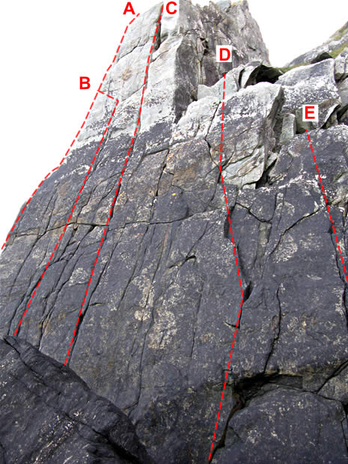
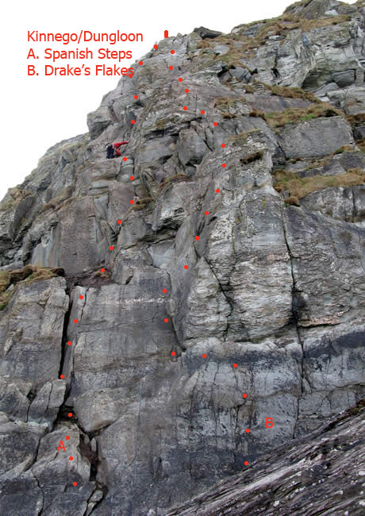

Austin's Window Routes

The routes West of, and beyond, the Black Wall.

A. The Floating World* , E2 5c, 18m. I & M Rea 89
B. Bedform Dynamics*, E1 5b, 18m. Miller, Dunlop, Grimes
C. Austin's Window***, E1 5b, 18m. Torrans, Sheridan 80
D. Dubloons* Sev 4a, 10m. Tees, Wray 80
E . Michelle X, Diff, 8m. B. & M. McDermott 79

Beyond, and west of, 'Austin's Window' etc there are two x 2 pitch routes

A. Spanish Steps, Sev 4a, 45m. Tees, Magowan
B.. Drakes Flakes*, VS 4b, 45m. Tees, Magowan

Beyond again are "Green Ice", " Missionary man" etc. and the committing and inaccessible routes of D' Illont's Wall.

Port a Doris Gr C686 437

Directions: Park at the lighthouse/shore carpark at Shroove, and walk northwards up the road to a small gate on the right (where the road bends back to the left). Walk down the field and pick up a coastal path, which brings you into the cove via a small rock doorway after 10 minutes approx. The main crag, comprising Circular Wall and Toby Jug Wall is straight ahead. This is an all weather crag, mostly easy routes that can be climbed when all else fails!
Routes opposite Door
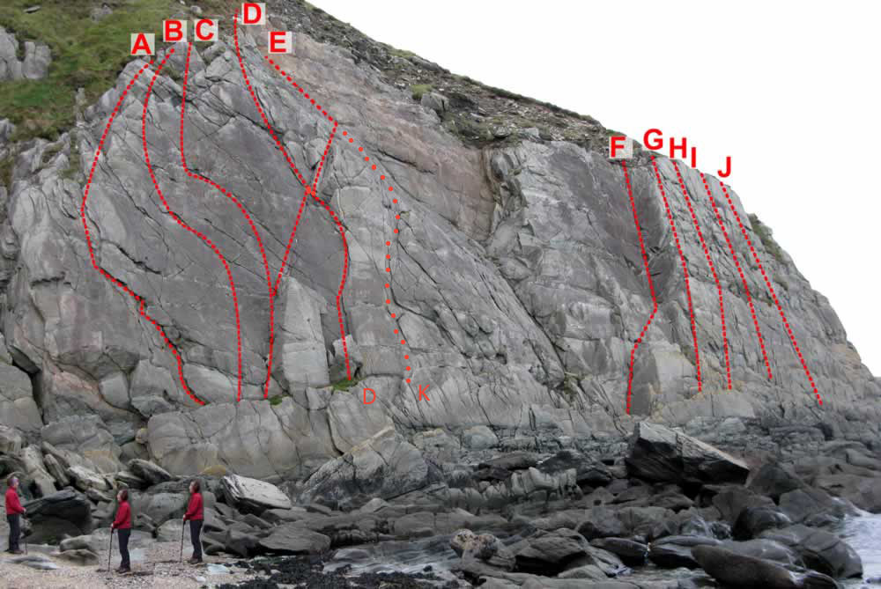

A. Cup Final Alternative* , V Diff, 25m. R.Smith, Tees 79
B.Dischord*, HS 4b, 25m. Stelfox, Turley 83
C. Storm Bringer*, HS 4b, 25m. Manson, Tees 79
D. Crack a Toa**, Sev 4a, 25m. Tees, R.Smith 79
E. Micro Wedge, Sev 4a, 20m. McCrory, Grant 79
F. Kelp, Sev 4a , 10m. Tees, R.Smith 79.
G. Purple Patch*, Diff, 20m. Hamilton, Tees 79
H .Chockstone Trundle , Diff, 20m. R.Smith, Tees 79
I. Juggernaut , Diff, 20m. R. Smith, Tees 79
J. Doughin Doris*, Diff, 20m. Tees, R.Smith 79
Routes beside Door (on the left)
A. Pauline's Crack , HS 4b, 10m. McDermott, McCrory 79
B. Thrills, HVS 5b, 10m. I. & M. Rea 89
C. Scarcasm, Sev 4a, 12m. Manson, Tees 79
D. Straw, VS 4b, 10m . I. & M. Rea 89
E. Novice Outing, Diff, 17m. Grant 79
F. The Crawler, Sev 4a, 15m. McDermott, McCrory 79
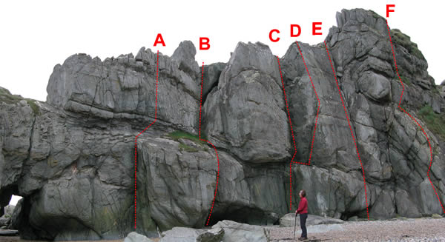
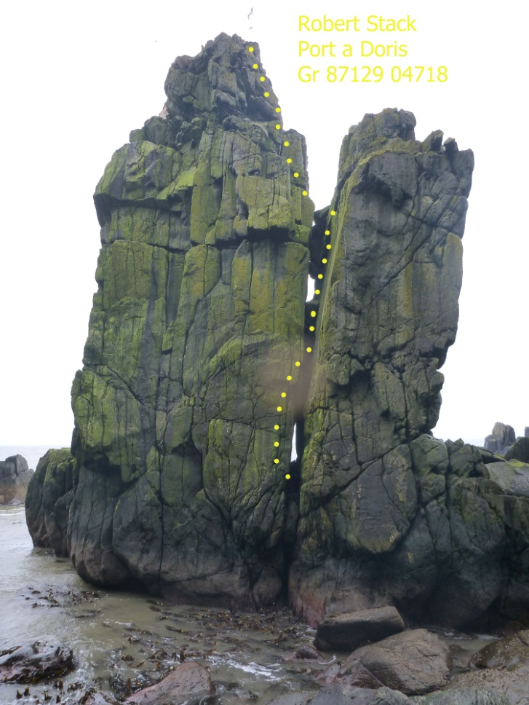

Robert Stack Gr87129 04718
Continue beyond Port a Doris past a cave, and a smaller stack to this dramatic split stack feature. There is also a cave here which leads into the next bay.
Route shown is "Windy Gap" Sev McFarlane, Turley, O'Hare 88
Access is through the fissure. Climb the outside left of the gap, and Chimney the rest. A great outing on a dry day.

There is another route "Ladas Drive" VS4b, which climbs the left wall of the fissure entrance.

The Music House. Glenagivne.
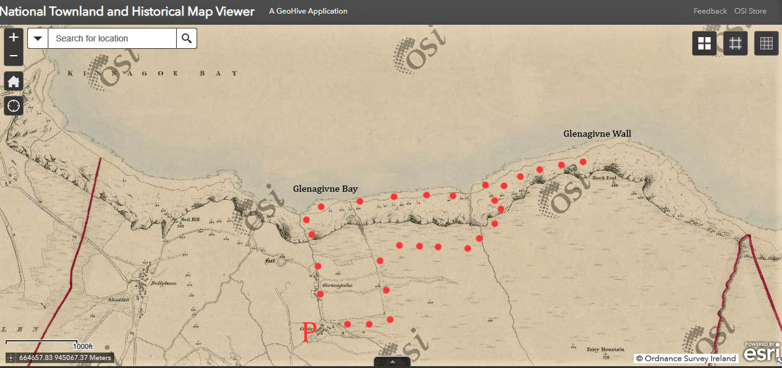
Topoguide. April 2022
Directions: This impressive wall rises in three tiers from just above sea level to the summit of Rock End at over 400m at the northern termination of Glenane Hill. Steep multi-cracked walls are capped by ‘The Beak’, a prominent spike at its highest point. The lowest tier, (The Music House) is probably the most impressive and attractive, and this is separated from the upper cliffs by a thin heathery terrace. There is a cave/alcove by the beginning of the terrace, should shelter be required ( and a shelter at the bottom under some boulders too). The middle wall, above, is also seamed with cracks which run through 2 bulges for most of its length. The upper wall is slabby, has a large prow, and the prominent ‘Beak’ at the top. Approach Turn off the Moville to Gleneely Road towards Kinnego bay, continue along the hilly coastal road east and park at Craig . Best approach is a coastal boulder hop from Glenagivne Beach (much easier when the tide is out and there are parts of beach to walk on). Park on a lane below some holiday cottages gr 639 454, walk further down the lane to a bend, and follow a path left, down through some woods, exiting by the river onto the stunning Glenagivne Beach. Walk to the east end of the beach and do a coastal traverse from there. Outside the growing season, there is an alternative route from Craig, use the rising track through 2 gates across Mr Anthony McHendry’s land, which is probably marginally shorter. Anthony’s house is known as the Music House. Just left of the gate at Gr 640 454 From the holiday cottages above Glenagivne bay, continue a short distance up the hill, and take the left of two side- by- side lanes, one of which is not marked on the OS map. At the end of the lane is another gate, and beyond is a track running left, down towards the sea. Take this and follow it as it bends to the right, until you come to a swampy area, from where a stream emanates. The ground to the left is wet, tussocky and rushy, but there are sheep paths (opposite a rusty tank) through it which descend to a fence at the top of the bens. Follow the fence to the right (east) to a grassy spur, and take a steep sheep track down the slopes to just above the sea. Five minutes further east will lead to Glenagivne Wall. This approach is about 40 minutes from the car.
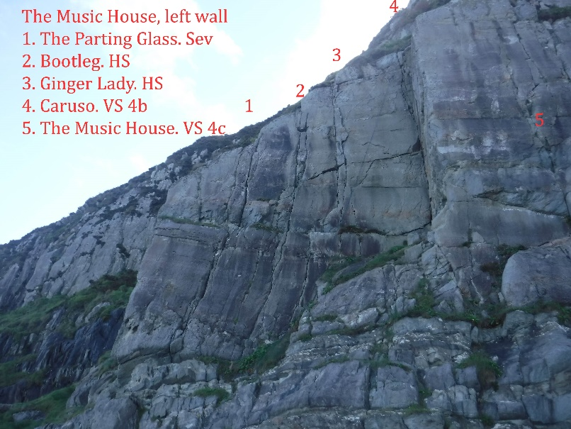
OS Grid Reference: Gr 650 459
Left wall

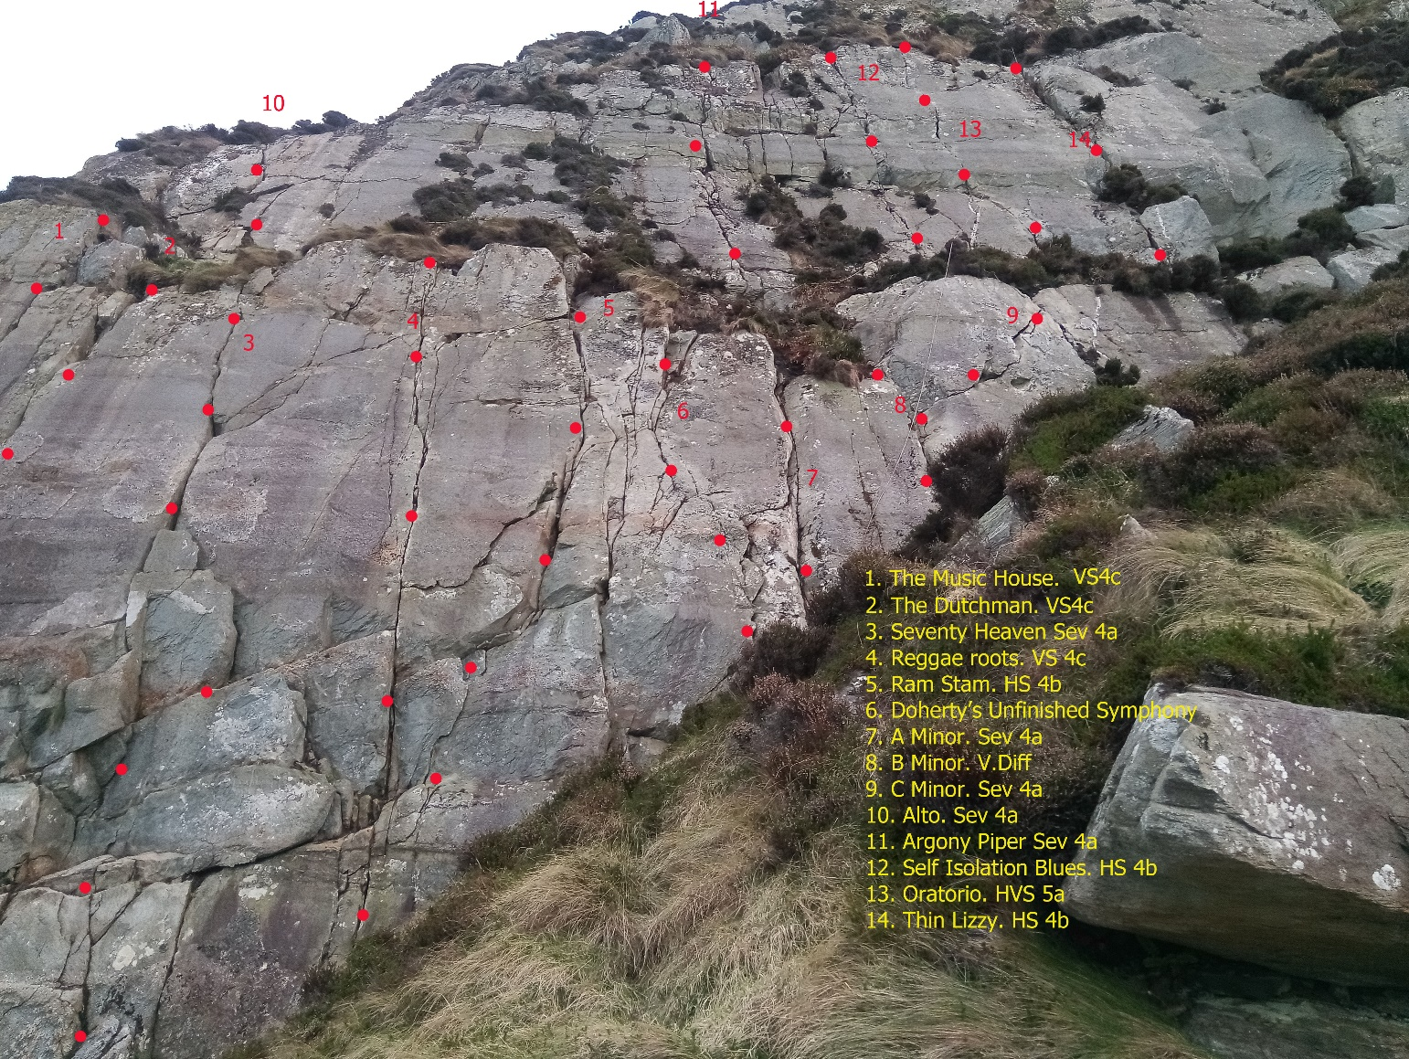
Main Wall

DUNAFF HEAD
Dunaff is a dramatic Headland on the North Inishowen coast. The huge north facing cliffs are mostly broken and vegetated, but a serrated spur is prominent, viewed from the east, and this is Binnastooka. The other main feature is the spectacular sea stack, Bothanvarra.
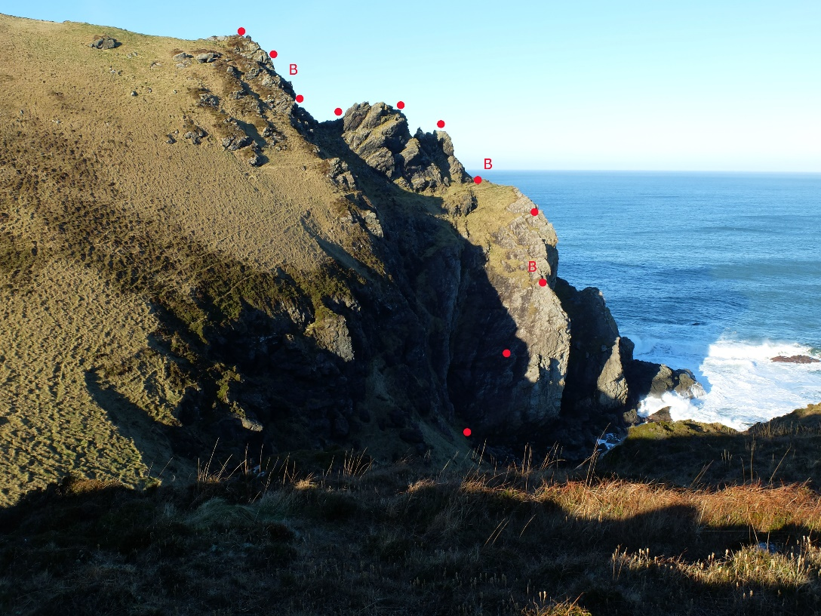
Directions: Through Clonmany in a westerly direction, parking at Rockstown Harbour 328484, by a stony beach. Walk west, past a small pier and cross a couple of unpleasant barbed wire fences to the first height. Beyond this a small stream descends north into the sea. Follow the west side of this to the shore and the base of a big slab.

OS Grid Reference: 319413

Binnastooka - 1955 route
Severe 3c
Length: 145m
NWMC 1955
Park at Rockstown Harbour 328484, by a stony beach. Walk west, past a small pier and cross a couple of unpleasant barbed wire fences to the first height. Beyond this a small stream descends north into the sea. Follow the west side of this to the shore and the base of a big easy- angled gravelly slab.
1.(60m) Easy climbing diagonally right , but with a big runout, to a belay at the edge. 2. (35m), easily up the edge, avoiding grass where possible, to the base of the first tooth. 3. (50m). Over the teeth and descend to a gully, which can be climbed up the middle, on the left, or with more difficulty on the right. This route appears in the NWMC 1955 log book

Isle of Doagh
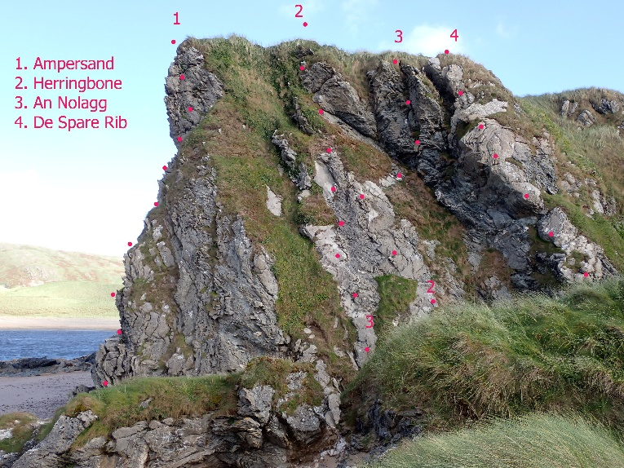
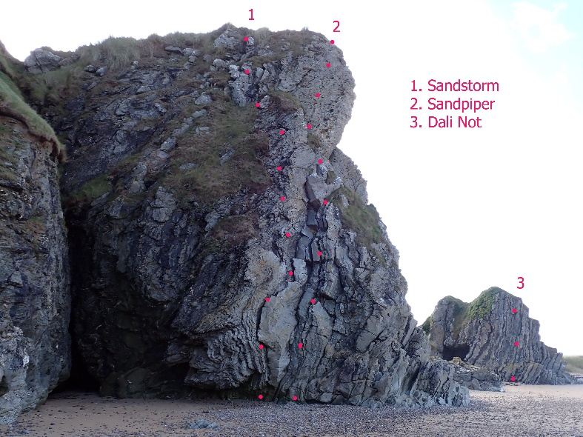
Isle of Doagh
The Lagghorn
Directions: This interesting crag is to be found on the beach at Doagh Island opposite the Five Finger Strand. Drive past Ballyliffin golf course onto Isle of Doagh, and park opposite the Irish famine village (come Santa’s grotto at Christmas). The crag can be found after a short walk west, along the beach from the car park, passing some excellent bouldering routes. The climbs are on two rocky towers at the end of the cliffy bit, the ‘Lagghorn’ and the ‘Kleine Lagghorn’, with nice sandy landings. Unique contorted rock, long thought to be unstable, provide excellent climbing in truly lovely surroundings.
Stakes are in situ at the top.
OS Grid Reference: C 421 519
1 - Sand Storm** VS 5a -Length: 20m. J Read, R Hurson (Climbfest 05 or 06)
2 -Sand Piper*** VS 4b -Length: 20m. S Read, E Ross (April 2005)
3- Ampersand ** Severe 4a. Length: 25m. Alan Tees, Neil Machon 2/04/21
4- An Nollagg. Severe 3c Length: 20m Alan Tees, Anthony Feeney, 25/12.2022
5.Herringbone. Severe 3c 20m. A. Acheson, N. Machon
6 - De Spare Rib. Severe 4a. Length: 25m. Alan Tees, Neil Machon 2/04/21
7 - Dali Not* HS 4b. Length: 10m. Alan Tees, George Beaumont

Malin Head
Travelling on the loop road around the head in an anti- clockwise, or Westerly direction, take the right turn just after the road up to Bamba's Crown (the prominent tower which marks Ireland's most northerly point), follow this track to park on the right before the boundary fence. The boundary fence was erected by the new absentee landlords, initially during the filming of Star Wars, but the fence has remained and been reinforced, denying access to an area that had previously been open to all. Walkers, fishermen, bird watchers, basking shark spotters, and unfortunately climbers have all been excluded. There were a substantial number of routes on the slabs, and a number of outstanding lines on the big sea stack called Skildren Mor, just off the coast. Details of these routes can be accessed on the Colmcille Climbers online guide, under Sea Area Malin.
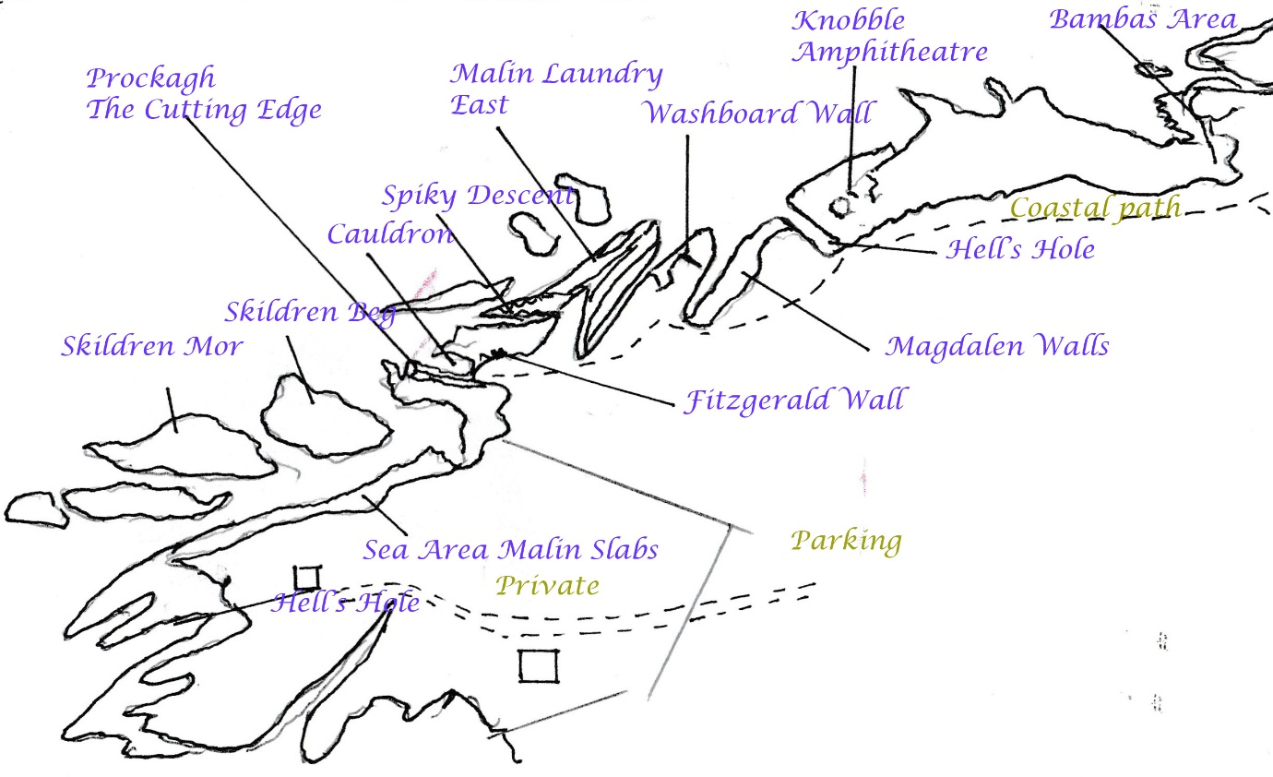

The Cauldron
Grid ref: C386592
Directions: Walk North for about five minutes to the highest part of the cliffs (Prockagh).
To the left is the prominent ‘Prockagh/Cutting Edge’ Ridge, with ‘Stelfox Slab’ dropping on its North side into 'The Cauldron'.
Descent for Stelfox Slab routes is by abseil from Gr 38670 59333, but the other routes further East can be accessed via a spiky ridge approx 100m east, (as for Malin Laundry) and a coastal scramble.
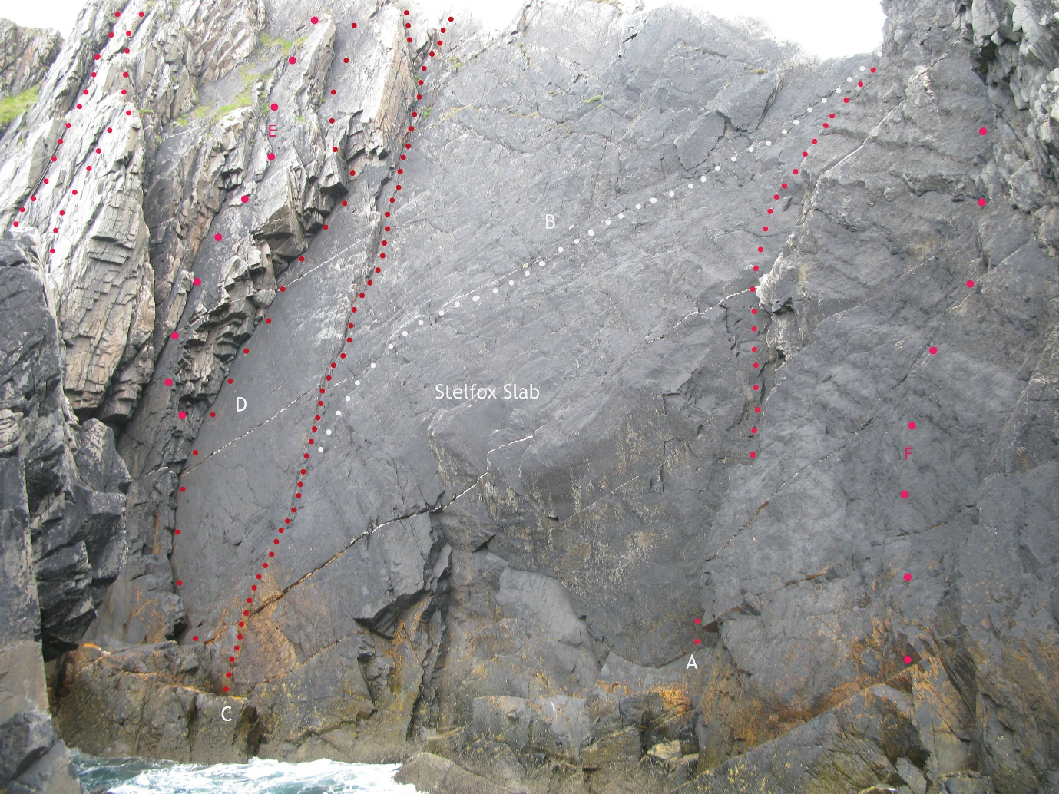
- Black Betty
- The Cutting Edge
- Dawson’s Diedre
- Rebel Yell
- Finnegan’s Rake
- Black Bush
Prockagh Ridge ** 140m V.Diff
First ascent: YHANI group 1939
Descend, next to, and left of, the ridge, to sea level and the western toe of the ridge.
1. 40m Scramble up the ridge to reach the large flakey belay on the 1st summit
2. 10m Move over the grassy top to belay on a small rock outcrop that provides a good observation point on the left, slightly lower than the grassy knoll on the crest of the ridge.
3. 40m The Dallas Pitch Go over the grassy knoll and descend a series of steps to belay in the col below. There is some loose rock at the top. This belay can be reached directly from the slopes below by a short scramble.
4. 40m The Blade. A cracking pitch. The way is obvious! Up the crest of the ridge, to where the ridge steepens. Up the rock to below the notch in the final gendarme and step out onto the southern face. Step up and stand on the top and start to smile for a photo before belaying.
5. 10m Descend carefully to base camp, and hopefully your lunch.
For the following routes, also descend the LHS of the ridge, but traverse around right, to a deep gully, with a steep wall on its right, named Conn’s Sheugh.

Infinity And Beyond ** 35m VS 4b
First ascent: Trevor Hartley and Alfie Conn 10/06/2012
Start at the upper end of the 'sheugh’. Descend a few metres until it is possible to use some quartz topped holds to traverse awkwardly left into the crack that continues to the top. (Suggestion: check which crack you are heading for by looking from the easy angled slab beforehand!). The crack is easier than the traverse and there is good protection. The rock is solid until the angle eases at the top. The route has also been climbed from the bottom of the Sheugh.
Razorbill *** 25m VS 4b
First ascent: Martin McGuigan, Alan Tees, 8/09/12
10 metres down the sheugh, and left of the Infinity routes, a spectacular crackline splits the highest part of the wall. Due to tide and swell. The first ascent was done from a hanging belay 3-4 metres above the bottom. The second ascent was done from the bottom (AT & MMcG).

Black Bush. 30m. HS 4a
Alan Tees, Geoff Thomas
From the western high point of the Prockagh Ridge, abseil down a corner to a slanting red ledge, just above the sea (calm weather only). Slippery. Climb directly to the corner above on reasonable holds and protection. The crux is about half way up the corner, and would be a grade harder in seepage.
The next route is accessed by abseil from the low point on Prockagh Arete/belay nick on Cutting Edge. Descend the left- hand side of the ridge to where a short steep climb leads up to the Nick. Abseil from here down into the Cauldron, to an orange ledge at sea level.
Black Betty 30m VS 4c
First ascent: Alan Tees, Alfie Conn 25/03/12
From the ‘Nick’, abseil down to an orange ledge in the 'Cauldron' from the lowest part of the 'Cutting Edge' ridge (seas permitting). Climb the corner/chimney on bombproof black rock, onto a large flake, and out left, thinly up the wall for a move or two to easier ground. Scramble up the slab above to the top.
The next routes require a 50m abseil from the landward end of ‘The
Cutting Edge’ Gr 38670 59333 down to a big ledge in the Cauldron. Care required not
to knock any rocks down on those below, (and also beware high seas).

The Cutting Edge *** 100m V.Diff
First ascent: Trevor Hartley and Alfie Conn. 10/4/2011
Most of the original route ‘Lizard Line’ can be combined with the best bit of Prockagh Ridge, to make one of the best routes of its grade in the country.
Abseil down Stelfox Slab (50m) to the large platform on its Eastern edge. Pitch 1. Ascend the line of the abseil to where you meet an obvious quartz traverse line, which runs rightwards across the face. Follow it to the nick in the ridge (55m). Pitch 2, climb the airy knife edge of ‘Cutting Edge’ to the highest point, and belay. Descend carefully to safer terrain.
Dawson's Diedre ** 50m Sev 4a
First ascent: D. Stelfox, R. Fenlon, V. McAlinden. Oct 2007
Abseil directly down Stelfox Slab, on its East side, to the platform above the sea, as per Cutting Edge (there can be alarmingly huge swells) and climb back up the crack and groove, taking the right angled corner to the left at the top. Excellent climbing in a spectacular location.
Rebel Yell * 70m HS 4b
First ascent: Alfie Conn and Trevor Hartley (Alt leads) 3/7/2011
Abseil down Stelfox Slab to the large platform. There is a large curving corner on the Eastern side of the slab. Pitch 1.(40m) 4b Climb the corner until a few metres below the capping overhang. Traverse right to belay on "Dawsons Diedre" just below its final chimney. Pitch 2. (30m) 4b. Traverse left below the overhang and turn it on the left side. Then ascend the slabs above getting quite loose near the top

Finnegan's Rake. VS 4b 60m
Start up 'Rebel Yell' and after about 8m, move left out onto the wall. A few tricky moves on sound rock and good wires lead up left onto the slab, just at the base of a prominent steep corner . Continue up, rightwards up the slab/ramp, mainly using the corner on the left, until better rock beckons on the arete near the top.
Alan Tees, Chris Boomer 10/06/12

The Following routes are still bounding The Cauldron, but are approached via the spiky descent ridge approximately 100m east, (as for Fitzgerald Wall) and a coastal scramble.
Malin Headcase 60m. Sev 4a
First ascent: Alan Tees, Bill Magowan, 3/08/11
Descend at the end of the Zawn of the Cauldron, to a non tidal ledge (Approx Gr 38673 59356). At the LHS, ascend steeply, and step right to a sloper, then onto easier ground, and continue up, fairly easily but with zero gear for a considerable spell, to the obvious corner high on the face (gear-Whew!). Above the corner, gain the arete and continue, with care, to the top.

Northern Exposure 60m Sev 4a
First ascent: A.Tees, M.McGuigan, B.Magowan, A.Conn 18/09/11
Descend as for ‘Malin Headcase’, to a non- tidal ledge, and a metre right of the’ Headcase’, climb another sound, black, corner with a good crack for protection. Continue up the obvious line of weakness, being pushed gradually right on a profusion of flat holds (gear still not wonderful). When the angle steepens near the top, the gear gets better, as you bridge up either side of a steep crack, to gain the arete. Belay. Continue up the arete with care.

Fitzgerald Wall (developed on the day of Garret Fitzgerald’s state funeral)
Mainly easy routes on good rock in an impressive situation. Descend the spiky Arete east of Fitzgerald Wall, descend left (west) and clamber your way across to the bottom of this small wall, which is climbable in everything but a full-on Malin Head gale (or Gael) and dries quickly. A good wet weather alternative. The alternative is a short abseil in from the top. Stakes in situ.
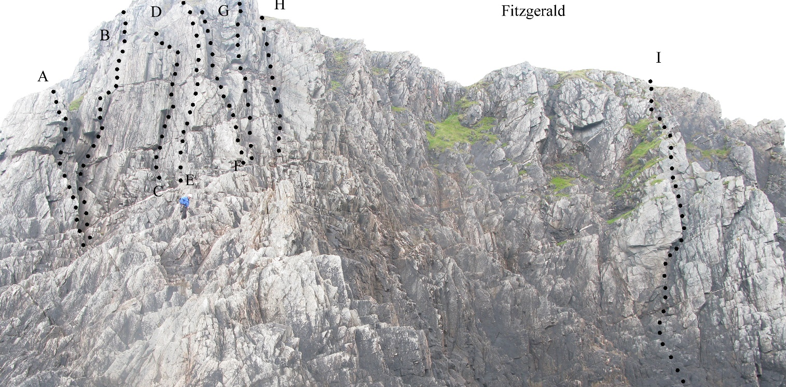

- No Holds Barred V Diff
- Geoff’s Route. HS4a
D Sunningael. V Diff
E. The Drying Game. V Diff
F. Garret’s Groove. Mod
G. Café Banba. Diff
H. Fine Gael. Diff
I. Malin Headcase. HS

Malin Laundry, East
This is the better of the two ’Laundry’ outcrops. The name derives from the blinding white foam thereabouts on a sunny day. The climbs are largely protected from the swells by a fin of rock, on which there are a couple of easy routes. Some excellent climbs on sound rock and protection.

Descend grassy/rocky ridge at gr 38822 59428, parallel with the sea, to opposite the most easterly and largest of three offshore islands. Either scramble down, or abseil to a long narrow pool/trough of seawater, separated from the sea by a fin of rock. Routes are described east to west, as it is usual to abseil down towards the east end.

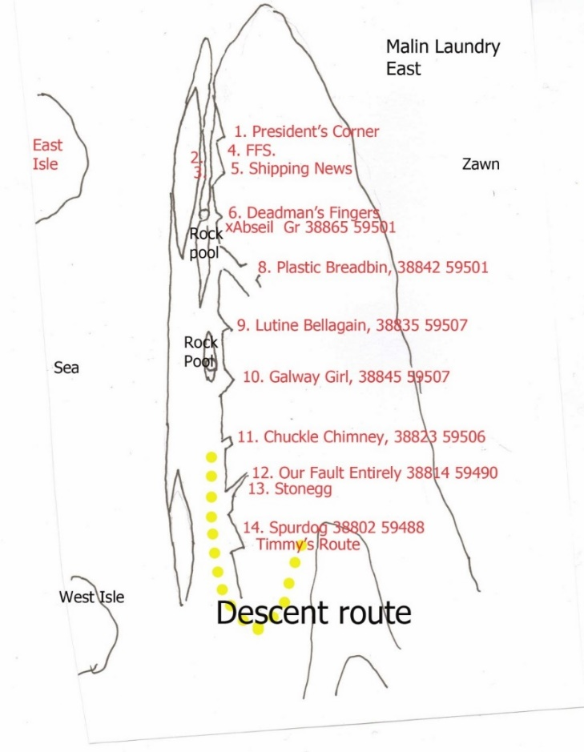
1. President's Corner, HVS 5a, 10m.
2. 2009, Rising, Diff, 15m.
3. Thirty foot Wall, Diff, 9m.
4. FFS, E1 5b, 13m.
5.Shipping News** VS 4b, 18m.
6. Deadman's Fingers*, VS 4b, 18m.
7. Arial. HS 4b, 12m.
8.Plastic Breadbin, Sev 4a, 14m.
9.Lutine Bella, Sev 4a, 20m.

10.Galway Girl, Sev 4a, 14m.
11.Chuckle Chimney, Diff, 8m.
12. Our Fault Entirely, Sev 4a. 13.Stonegg, VS 4c, 15m.
14.Spurdog/Timmy's Route, V,Diff, 8m.
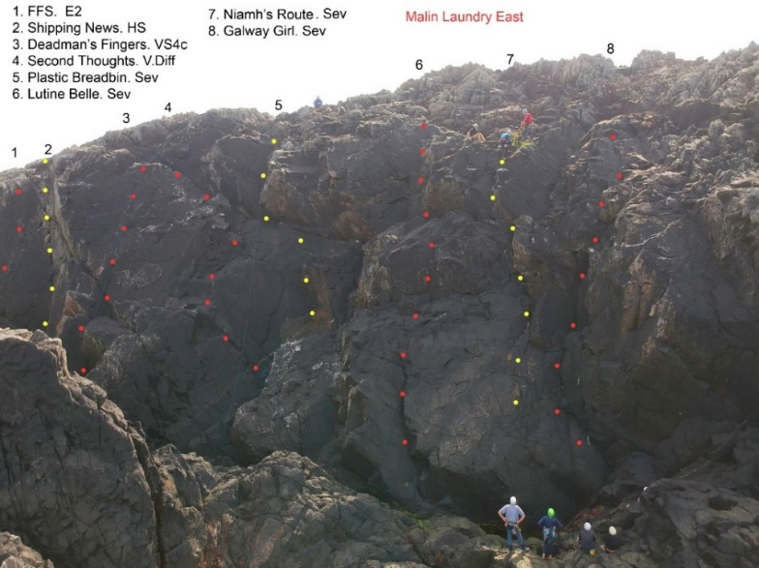

Malin Head (Magdalen Walls)

Continuing the Laundry Theme
Grid ref: 3895 5950
Directions: Magdalen Walls
This is the area east of the 'Malin Laundry' and just west of Hell's Hole. The shortest approach is to park at the lower car park at Bamba's Crown and take the coastal path west for about 10 minutes. Just beyond Hell's hole (a deep inlet) scramble down the rocks to the cliff top and abseil, or descend carefully further to the west, taking care particularly on the big tidal platform, which is usually slippery. After a high tide the bottom of the routes can also be wet. The two walls are divided by a deep chimney/off width. The routes are short, but on sound black rock. There is one route within ‘Hells Hole’, on its eastern wall. Descent is by abseil, close to the mouth of the inlet, to a tidal platform in very calm weather. ‘The Devil Rides out’. HS4b
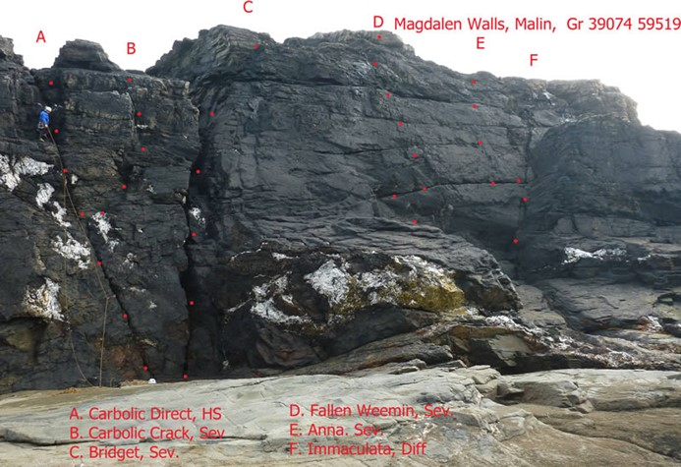
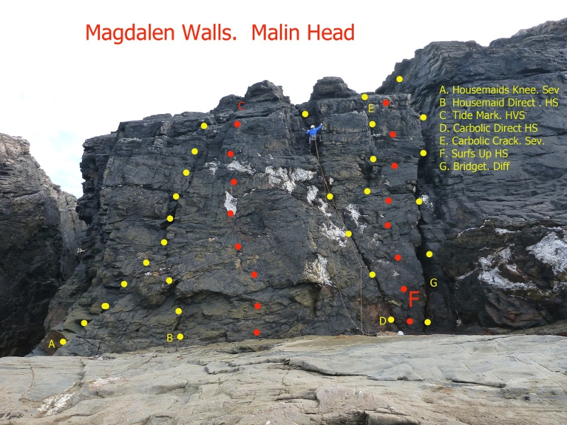

Magdalen Wall West
A.Housemaid's Knee, Sev 4a, 12m.
B. Housemaid Direct. HS 4b, 12m
C. Tide Mark. HVS 5a 12m
D. Carbolic Direct, HS 4a, 12m.
E Carbolic Crack* Sev 4a, 12m.
F. Surfs up. HS 4b 12m
G. Bridget, Sev 4a, 16m.

